Information on COVID-19 Pandemic

- All Athletes and grooms have to fill in a form „attendance confirmation“. This form is part of the schedule and MUST be given completely filled in and signed to the entrance control on arrival. Without this form nobody is allowed to enter the showground. On arrival everybody will get the accreditation and a mouth-nose mask. This mask must be worn at all indoor places.

- Per Athlete only 1 groom per 2 horses will get an accreditation. Owners and spectators will not get access to the showground in order to limit the access of people in accordance with the official restrictions from the government.

- To comply with the government requirements all people on the showground have to keep a minimum of 1,5 m social distance from other people.

- Only people without any illness symptoms which are typical for a COVID-19 disease will get access to the showground.

CONTACT RESTRICTIONS

Summary of the „Baden-Württembergische Verordnung zum Schutz vor Neuinfektionen mit dem Corona-Virus” vom 8.3.21 (Baden-Württembergische regulation on protection against new infections with the corona virus, 8.3.21)

§ 1 Abs. 1: Each person has to minimize strictly all physical contacts to all other people who do not belong to the family of one household.
§ 2 Abs. 1 Contacts of persons are only allowed by following the rules of paragraph 2 and 3.
§ 2 Abs. 2 At public places including free movement of people each person has to keep a minimum distance of 1,5 m to all other persons. This also applies to physical and athletic outdoor activities but not with persons living at the same home like the liable person. A mode of behaviour at public places which will endanger the distance rule by the opening paragraph 1 is strictly forbidden. This applies especially to groups of people…..
§ 2 Abs. 3 Meetings and crowds at public places are limited to a maximum of 2 people; exception: meeting of families and people living at the same home….

Non-compliance can be punished by monetary fines.

The non-observance of these rules and information is a violation of LPO § 920, 2.k (German Show rules) and can be punished with a regulatory measure by § 921 LPO.

Responsible for hygiene factors: Dr. Hannah Gorre, Dr. Irina De Jong

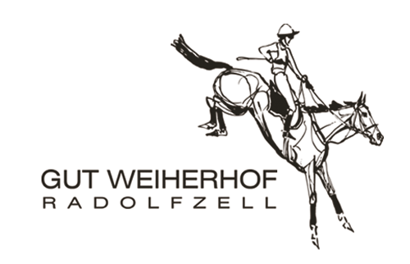

Attendance confirmation

For the showground (Radolfzell, Gut Weiherhof) under the provisions of § 6-12 IfSG (Infektionsschutzgesetz – adhere to the law against infection) on the occasion of Corona / COVID-19

This form MUST be filled in to get access to the showground.

First name, surname: ___________________________________

Street: ____________________________________

City and postal code ____________________________________

Function: ____________________________________

Email address: ____________________________________

Mobile number: _____________________________________

I only give permission to forward and save my data to the responsible authority of health for the traceability of possibly occurring infections.
The transfer to a third party is not permitted.
I oblige myself to follow all published and signed disinfection rules, social distance rules and mouth-nose mask rules.

________________________ __________________________
Signature Date, Place

